**Ideation Phase**

**Brainstorm & Idea Prioritization Template**

|  |  |
| --- | --- |
| Date | 19 September 2022 |
| Team ID | PNT2022TMID43281 |
| Project Name | Real-Time Communication System Powered By AI For Specially Abled |
| Maximum Marks | 4 Marks |

**Brainstorm & Idea Prioritization**

Brainstorming provides a free and open environment that encourages everyone within a team to participate in the creative thinking process that leads to problem solving. Prioritizing volume over value, out-of-the-box ideas are welcome and built upon, and all participants are encouraged to collaborate, helping each other develop a rich amount of creative solutions.

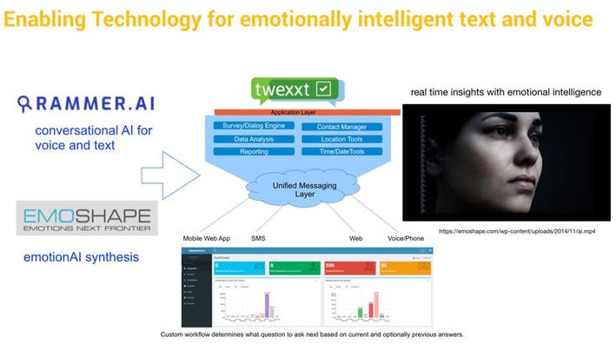

Human beings can communicate with one another via natural language channels including words and writing, or through body language (gestures) like hand gestures, head gesticulations, facial expressions, lip motion, and so forth. Learning to read and write in normal language is essential but knowing sign language is equally essential. Individuals who are partially deaf rely on sign language as their primary mode of communication. People who have hearing impairments have difficulty communicating with those who do not have hearing issues if they do not have access to a translator [1]. This is why the deaf community will benefit greatly from a technology that understands sign language especially hand gestures. Even though mobile technology is rapidly evolving and becoming incredible, there has been little technological advancement and development for artificial intelligence voice-based smart devices that can assist deaf people in understanding and responding to their body language. When combined with learning algorithms, ubiquitous sensing may be used to integrate all of the body language information

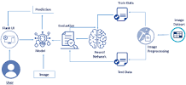

**Brainstorm, Idea Listing and Grouping**

Machine learning takes data and looks for underlying trends. If it spots something that is relevant for a practical problem, software designers can take that knowledge and use it to analyze specific issues. All that is required are data that are sufficiently robust that algorithms can discern useful patterns. Data can come in the form of digital information, satellite imagery, visual information, text, or unstructured data.

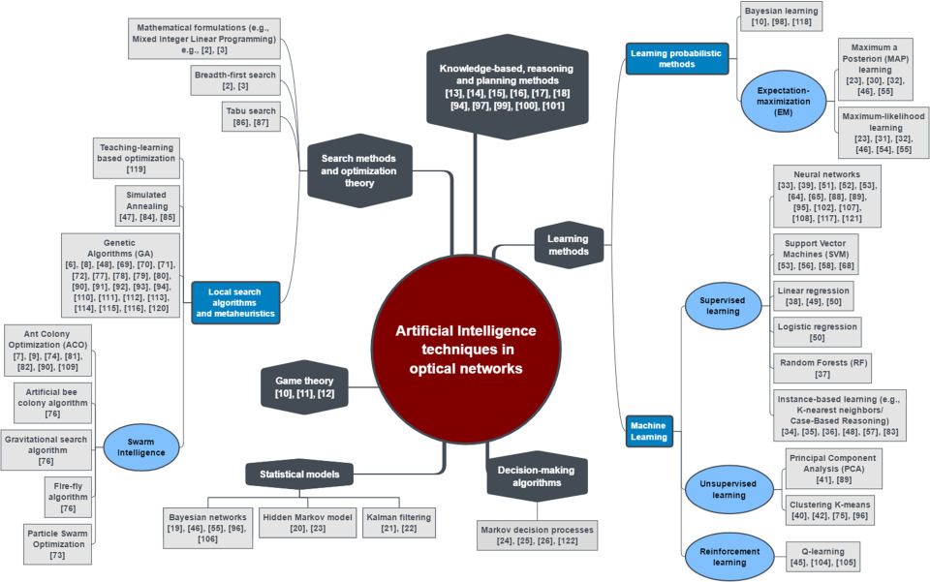

A prominent example of this is taking place in stock exchanges, where high-frequency trading by machines has replaced much of human People submit buy and sell orders, and computers match them in the blink of an eye without human intervention. Machines can spot trading inefficiencies or market differentials on a very small scale and execute trades that make money according to investor instructions

**AI Approach and Application in Mobile Communication**

There are some classic artificial intelligence approaches, such as fuzzy logic and neural network. Then, the neural network would be extended to be better performance techniques such as machine learning and deep learning approaches. The basic approach is Fuzzy logic, which is processed any values and resulting in true and false. Another term in AI is reinforcement learning, a technique to design a computer or machine for learning by itself instead of being precisely programmed [12]. One of the techniques is Neural networks (NN). This technique can be made by a machine or computer able to self-learning to solve a problem. NN process adopts the brain human system and behavior

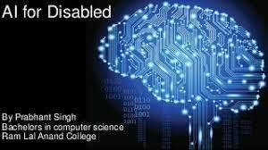

Polly can attach to any wheelchair or bedside, track eye movement and use ML to assist smart prediction of the user's needs and wants. As per a 2011 WHO report, 15 percent of the global population lives with some form of disability

‘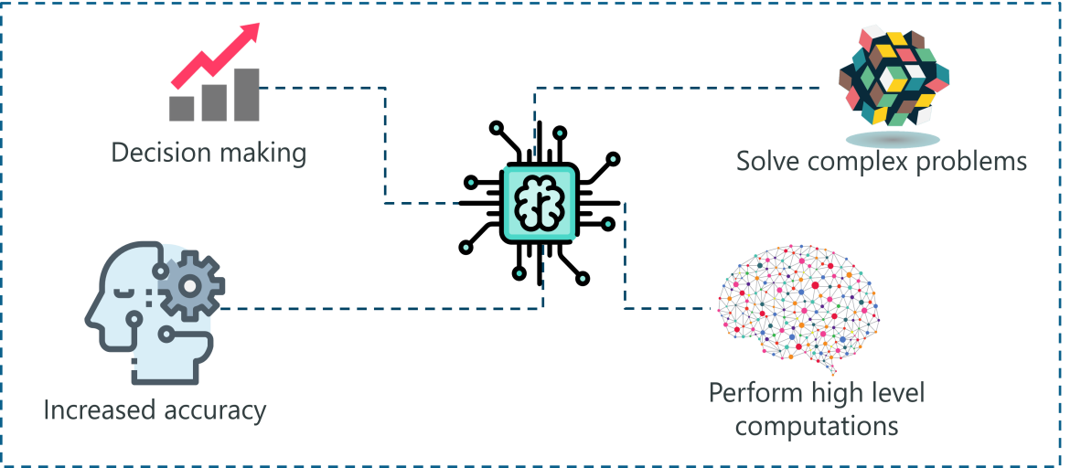

* Decision making in Mobile Communication
* Resource optimization in Mobile Communication
* Network management in Mobile Communication
* Other AI Application

Polly can attach to any wheelchair or bedside, track eye movement and use ML to assist smart prediction of the user's needs and wants. As per a 2011 WHO report, 15 percent of the global population lives with some form of disability

**Idea Prioritization**

* Machine Learning
* Deep Learning
* Natural Language Processing
* Robotics
* Expert Systems
* Fuzzy Logic

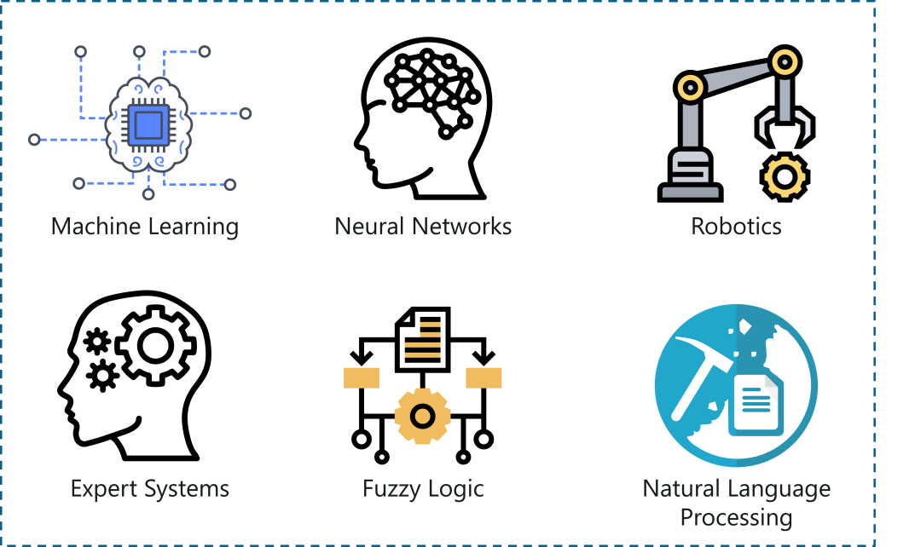

**Machine Learning**

*Machine Learning is the science of getting machines to interpret, process and analyze data in order to solve real-world problems.*

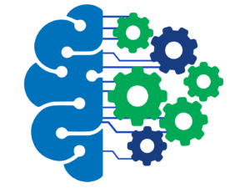

Under Machine Learning there are three categories:

1. Supervised Learning
2. Unsupervised Learning
3. Reinforcement Learning

To learn more about Machine Learning, you can go through the following blogs:

**Deep Learning**

Deep Learning is the process of implementing Neural Networks on high dimensional data to gain insights and form solutions. Deep Learning is an advanced field of Machine Learning that can be used to solve more advanced problems.

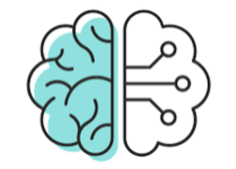

Deep Learning is the logic behind the face verification algorithm on Facebook, self-driving cars, virtual assistants like Siri, Alexa and so on.



In this paper wheel chair is designed which is based on accelerometer MPU 6050 sensor, the arduinonano board and estimated the analog values. From the obtained results the analog variables are calculated and made to transmitted over RF433MHz transmitter, then the transmitter values are read by the RF 433MHz receiver. Arduinouno board connected to move in four direction